 Fred C Andersen Canoe Trip (Day trip)

PREPARATION
- At least one adult leader must take the on-line Safety Afloat training through my.scouting.org
- Everyone on the trip must wear a Personal Floatation Device (PFD) at all times.
- Canoes can be rented at Fred C Andersen Scout Camp through the Northern Star Council website. Canoe rental is $15 per canoe per day, including paddles and PFDs. Canoe trailer rental is $25 per day. When renting a trailer, the unit needs to rent at least half of the trailer full of canoes, to ensure there are enough trailers for others that need canoes. Trailers hold 6 or 8 canoes.
- Swimming Ability – Every participant who intends to train for or paddle a solo kayak or canoe at a Scouting function must be classified as a swimmer by completing the 100-yard BSA swimmer classification test. For activity afloat, those not classified as swimmers are limited to multi-person craft during outings or float trips on calm water with little likelihood of capsizing or falling overboard. They may ride as a buddy in a tandem paddlecraft with an adult swimmer skilled in that craft.
- Canoeing Ability - Participants should have basic canoeing skills before paddling down rivers. Even if your troop is not camping at a Council camp, you may be able to rent the canoes there to practice on a local lake.
- Float Plan - Before Scouts go afloat, they develop a float plan detailing their route, time schedule, and contingency plans and share it with someone not on the trip. The float plan considers all possible water and weather conditions and all applicable rules or regulations, and is shared with all who have an interest.
- Water Levels - Most springs, the water level can be quite high. During normal water levels, the St. Croix River flows 1 - 3 mph. During high water, it can also get pretty fast (~6mph).

THE TRIP
- Meet at Fred C Andersen Scout Camp. You can reserve overnight camping or cabins through the Northern Star Council website.
- At least one vehicle will have to be left at Fred C Andersen Scout Camp so plan your rides accordingly. One vehicle must be capable of pulling the trailer loaded with canoes.
- Drive to the Somerset Landing, 261 Ferry Landing Rd, Somerset, WI with the canoes and gear for the day. This is about 13 miles from Fred C Andersen Scout Camp at river mile 35.7. There is plenty of parking here. This is the start of the trip.
- Canoe downstream to Fred C Andersen Scout Camp. Stay to the Wisconsin shore after the high bridge as there are many islands in this part of the St. Croix River.
- The trip ends at Fred C Andersen Scout Camp at river mile 27.

MORE INFORMATION AND MAPS FOR THE ST. CROIX RIVER
https://www.dnr.state.mn.us/watertrails/stcroixriver/lower.html

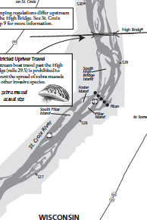
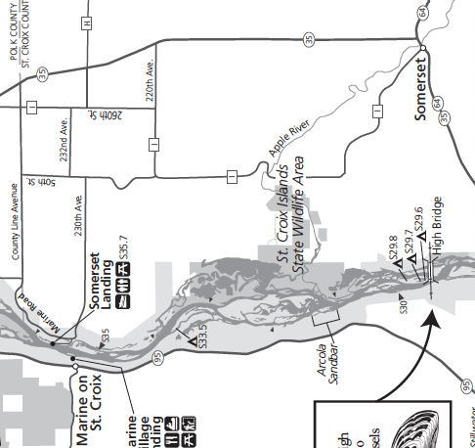



Fred C Andersen Canoe Trip (Overnight)

PREPARATION
- At least one adult leader must take the on-line Safety Afloat training through my.scouting.org
- Everyone on the trip must wear a Personal Floatation Device (PFD) at all times.
- Canoes can be rented at Fred C Andersen Scout Camp through the Northern Star Council website. Canoe rental is $15 per canoe per day, including paddles and PFDs. Canoe trailer rental is $25 per day. When renting a trailer, the unit needs to rent at least half of the trailer full of canoes, to insure there are enough trailers for others that need canoes. Trailers hold 6 or 8 canoes.
- Swimming Ability – Every participant who intends to train for or paddle a solo kayak or canoe at a Scouting function must be classified as a swimmer by completing the 100-yard BSA swimmer classification test. For activity afloat, those not classified as swimmers are limited to multi-person craft during outings or float trips on calm water with little likelihood of capsizing or falling overboard. They may ride as a buddy in a tandem paddlecraft with an adult swimmer skilled in that craft.
- Canoeing Ability - Participants should have basic canoeing skills before paddling down rivers. Even if your troop is not camping at a Council camp, you may be able to rent the canoes there to practice on a local lake.
- Float Plan - Before Scouts go afloat, they develop a float plan detailing their route, time schedule, and contingency plans and share it with someone not on the trip. The float plan considers all possible water and weather conditions and all applicable rules or regulations, and is shared with all who have an interest.
- Water Levels - Most springs, the water level can be quite high. During normal water levels, the St. Croix River flows 1 - 3 mph. During high water, it can also get pretty fast (~6mph).
- Camping Permit - You must apply for a free, annual camping permit from the National Park Service to camp in this area of the river. Apply well in advance of your trip so you have your permit before the trip. Information at https://www.nps.gov/sacn/planyourvisit/camping-below-highway-8.htm

THE TRIP
- Meet at Fred C Andersen Scout Camp. You can reserve overnight camping or cabins through the Northern Star Council website.
- At least one vehicle will have to be left at Fred C Andersen Scout Camp so plan your rides accordingly. One vehicle must be capable of pulling the trailer loaded with canoes.
- Drive to Wisconsin Interstate Park or Minnesota Interstate State Park to begin the trip(approximately river mile 52). There is a boat launch in each park. Both parks require an entrance permit. This is the start of the trip
- Canoe downstream. There are several campsites between river mile 43 and 40 including two group campsites. This is a National Park so individual sites are limited to 8 people and group campsites are limited to 16 people and there are other regulations. You need a camping permit well in advance of your trip (see above) but the sites are free. Campsites are first come, first served and have no reservations so you may have to search for a campsite.
- After camping, continue downstream to Fred C Andersen Scout Camp at river mile 27 for the takeout.

MORE INFORMATION AND MAPS FOR THE ST. CROIX RIVER
https://www.dnr.state.mn.us/watertrails/stcroixriver/lower.html

